Thread Synchronization
In the real world, you don't usually have the luxury of starting a thread and just letting it run. More often than not, that thread must coordinate its actions with other threads in the application. If two threads share a linked list, for example, accesses to the linked list must be serialized so that both threads don't try to modify it at the same time. Simply letting a thread go off and do its own thing can lead to all sorts of synchronization problems that show up only randomly in testing and that can often be fatal to the application.
Windows supports four types of synchronization objects that can be used to synchronize the actions performed by concurrently running threads:
- Critical sections
- Mutexes
- Events
- Semaphores

Critical Sections
The simplest type of thread synchronization object is the critical section. Critical sections are used to serialize accesses performed on linked lists, simple variables, structures, and other resources that are shared by two or more threads. The threads must belong to the same process, because critical sections don't work across process boundaries.
The idea behind critical sections is that each thread that requires exclusive access to a resource can lock a critical section before accessing that resource and unlock it when the access is complete. If thread B attempts to lock a critical section that is currently locked by thread A, thread B blocks until the critical section comes free. While blocked, thread B waits in an extremely efficient wait state that consumes no processor time.
The diagram in Figure 1 illustrates how the critical section prevents overlapping read and write accesses by serializing the threads' actions.
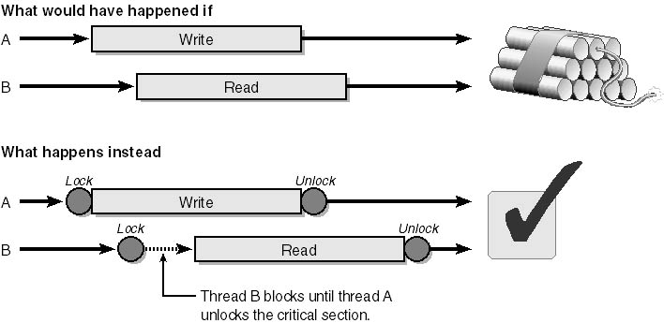
Figure 1. Protecting a shared resource with a critical section.

Mutexes
Mutex is a contraction of the words mutually and exclusive. Like critical sections, mutexes are used to gain exclusive access to a resource shared by two or more threads. Unlike critical sections, mutexes can be used to synchronize threads running in the same process or in different processes. Critical sections are generally preferred to mutexes for intraprocess thread synchronization needs because critical sections are faster, but if you want to synchronize threads running in two or more different processes, mutexes are the answer.
Suppose two applications use a block of shared memory to exchange data. Inside that shared memory is a linked list that must be protected against concurrent thread accesses. A critical section won't work because it can't reach across process boundaries, but a mutex will do the job nicely.
There is one other difference between mutexes and critical sections. If a thread locks a critical section and terminates without unlocking it, other threads waiting for the critical section to come free will block indefinitely. However, if a thread that locks a mutex fails to unlock it before terminating, the system deems the mutex to be "abandoned" and automatically frees the mutex so that waiting threads can resume.

Events
An event is little more than a flag in the operating system kernel. At any given time, it can be in either of two states: raised (set) or lowered (reset). A set event is said to be in a signaled state, and a reset event is said to be nonsignaled.
Events are sometimes described as "thread triggers." One thread calls Lock to block on an event and wait for it to become set. Another thread sets the event and thereby releases the waiting thread. Setting the event is like pulling a trigger: it unblocks the waiting thread and allows it to resume executing. An event can have one thread or several threads blocking on it, and if your code is properly written, all waiting threads will be released when the event becomes set.
Windows supports two different types of events: autoreset events and manual-reset events. The difference between them is very simple, but the implications are far-reaching. An autoreset event is automatically reset to the nonsignaled state when a thread blocking on it is released. A manual-reset event doesn't reset automatically; it must be reset programmatically. The rules for choosing between autoreset and manual-reset events—and for using them once you've made your selection—are as follows:
- If just one thread will be triggered by the event, use an autoreset event and release the waiting thread with SetEvent. There's no need to call ResetEvent because the event is reset automatically the moment the thread is released.
- If two or more threads will be triggered by the event, use a manual-reset event and release all waiting threads.
It's vital to use a manual-reset event to trigger multiple threads. Why? Because an autoreset event would be reset the moment one of the threads was released and would therefore trigger just one thread. If you use SetEvent and ResetEvent, you have no guarantee that all waiting threads will be released.
So how do you use events to synchronize threads? Here's an example involving one thread (thread A) that fills a buffer with data and another thread (thread B) that does something with that data. Assume that thread B must wait for a signal from thread A saying that the buffer is initialized and ready to go. An autoreset event is the perfect tool for the job.
Thread B calls Lock to block on the event object. Thread A calls SetEvent when it's ready to release thread B. Figure 2 shows what happens as a result.
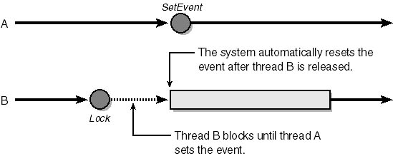
Figure 2. Triggering a thread with an autoreset event.
Sometimes events aren't used as triggers but as primitive signaling mechanisms. For example, maybe thread B wants to know whether thread A has completed some task, but it doesn't want to block if the answer is no. Thread B can check the state of an event without blocking by passing WaitForSingleObject the event handle and a time-out value of 0.
One caveat to be aware of when using an event in this manner is that if thread B will be checking the event repeatedly until it becomes set, make sure that the event is a manual-reset event and not an autoreset event. Otherwise, the very act of checking the event will reset it.

Semaphores
The fourth and final type of synchronization object is the semaphore. Events, critical sections, and mutexes are "all or nothing" objects in the sense that Lock blocks on them if any other thread has them locked. Semaphores are different. Semaphores maintain resource counts representing the number of resources available. Locking a semaphore decrements its resource count, and unlocking a semaphore increments the resource count. A thread blocks only if it tries to lock a semaphore whose resource count is 0. In that case, the thread blocks until another thread unlocks the semaphore and thereby raises the resource count or until a specified time-out period has elapsed. Semaphores can be used to synchronize threads within a process or threads that belong to different processes.
The statement: CSemaphore g_semaphore (3, 3)constructs a semaphore object that has an initial resource count of 3 (parameter 1) and a maximum resource count of 3 (parameter 2). If the semaphore will be used to synchronize threads in different processes, you should include a third parameter assigning the semaphore a name. An optional fourth parameter points to a SECURITY_ATTRIBUTES structure (default=NULL).
As long as no more than three threads try to access the resource at the same time, Lock won't suspend the thread. But if the semaphore is locked by three threads and a fourth thread calls Lock, that thread will block until one of the other threads calls Unlock. (See Figure 3.) To limit the time that Lock will wait for the semaphore's resource count to become nonzero, you can pass a maximum wait time (in milliseconds, as always) to the Lock function.
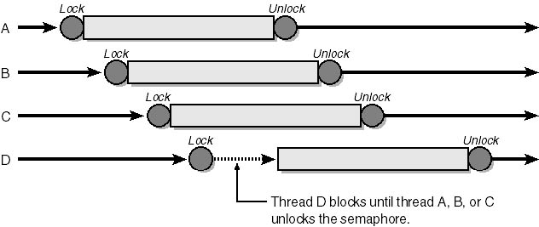
Figure 3. Using a semaphore to guard a shared resource.
A classic use for semaphores is to allow a group of m threads to share n resources, where m is greater than n. For example, suppose you launch 10 worker threads and charge each with the task of gathering data. Whenever a thread fills a buffer with data, it transmits the data through an open socket, clears the buffer, and starts gathering data again. Now suppose that only three sockets are available at any given time. If you guard the socket pool with a semaphore whose resource count is 3 and code each thread so that it locks the semaphore before claiming a socket, threads will consume no CPU time while they wait for a socket to come free.

